Platinum Buckle -Title Sponsor $25,000

VIP Perks: VIP Parking , Special seating & 20 tickets to the event. Recognition: Listing as Platinum Buckle Sponsor of Event on social media, premiere placement of name/company logo on Amy’s Wish website as Platinum Buckle Sponsor, audio/visual recognition on evening of event. Company Logo prominently displayed on the event T-shirts and 6 free t-shirts. Premier Signage at Amy’s Wish barn for one year. Event Signage: Premier signage at event and full page ad in program. Emcee Recognition: Evening of event. Receive 2 Platinum Level Belt Buckles
Diamond Buckle $15,000
VIP Perks: 16 tickets to the event. Recognition: Listing as Diamond Buckle Sponsor of Event on social media and placement of company logo on Amy’s Wish website as Diamond Buckle Sponsor, audio/ visual recognition on evening of event. Company logo displayed on the event T-shirts. Signage at Amy’s Wish Barn for one year Event Signage: Signage at event and half page ad in program Emcee Recognition: Evening of event. Receive 1 Diamond Level Belt Buckle
Gold Buckle $10,000
VIP Perks: 10 tickets to the event. Recognition: Listing as Gold Buckle Sponsor of Event on social media, placement of company logo on Amy’s Wish website as Gold Level Sponsor, audio/ visual recognition on evening of event & Company name displayed on the event T-shirts. Event Signage: Signage at event and half page ad in program Receive 1 Gold Level Belt Buckle.
Silver Buckle $5,000
VIP Perks: 8 tickets to the event. Recognition: Listing as Silver Buckle Sponsor on social media and website, audio/visual recognition on evening of event & Company name displayed on the event T-shirts. Event Signage: name on event signage, listing in program.
Bronze Buckle $2500
VIP Perks: 6 tickets to the event. Recognition: Recognition as Bronze Buckle on social media, audio/visual recognition on evening of event Event Signage: name on event signage, listing in program
Ruby Buckle $1,000
VIP Perks: 4 tickets to the event. Recognition: Recognition as Ruby Buckle Sponsor on social media, audio/visual recognition on evening of event Event Signage: listing in program
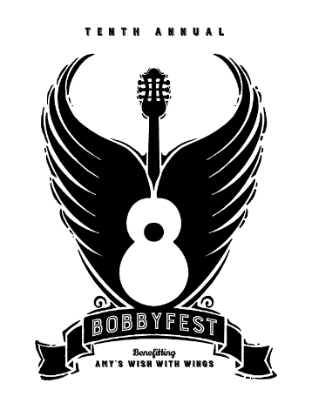

YES! I would like to help sponsor the 2023 BOBBYFEST MUSIC FESTIVAL. I have checked my sponsorship level below:
- $25,000 Platinum Title  - $15,000 Diamond  - $10,000 Gold  - $5,000 Silver  - $2,500 Bronze | - $1,000 Ruby  - $500 Donation  - $100 Donation  - Other $____________________

Name: ________________________________________________________________________
Company Name (if applicable):
_________________________________________________________________________________
Name as you would like to be listed for publicity:
_________________________________________________________________________________
Address: ______________________________________________________________________

City/State/Zip: _______________________________________________________________

Phone(s): _____________________________________________________________________

Email: _________________________________________________________________________
Thank You For Your Support! The deadline for inclusion in the printed program and event signage is April 17, 2023.
Payments can be made on our secure website www.amyswishwithwings.com
Or you can enclose a check made payable to Amys Wish With Wings
Mail to: Amys Wish With Wings 480 West Highland Street Southlake TX 76092

Amy’s Wish With Wings is a 501(c)(3) organization and your donation is deductible to the extent allowed by law.

BobbyFest Silent Auction or In-Kind Donation

YES! I would like to donate a Silent Auction or In-Kind Donation item for the BOBBYFEST MUSIC FESTIVAL.
SILENT AUCTION DONATION:
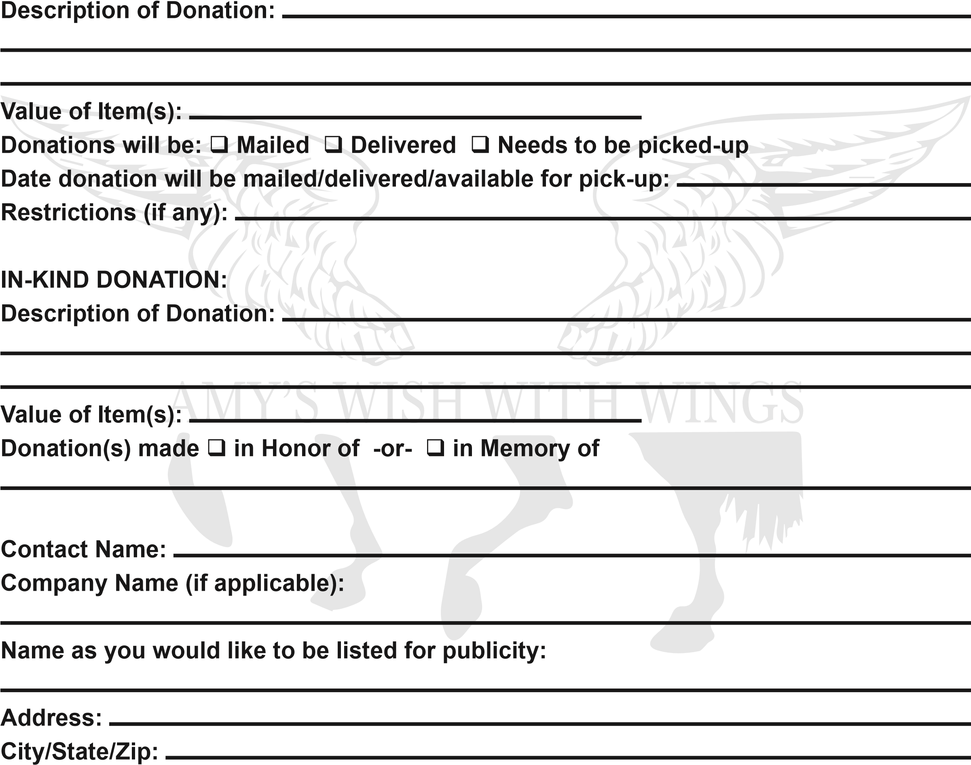
Phone(s):
Email:
Please return this form to: Amys Wish With Wings
480 West Highland Street
Southlake, TX 76092
Phone: (817)999-8332 Email: amyswishwithwings@gmail.com The deadline for inclusion in the printed program and event signage is April 17th Amy’s Wish With Wings is a 501(c)(3) organization and your donation is deductible to the extent allowed by law.

